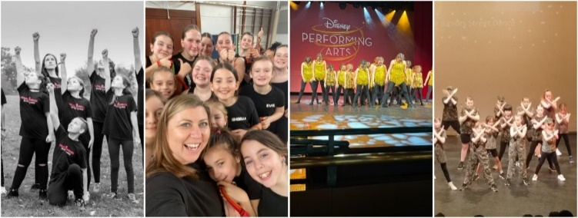
Please see our schedule below
Start back on Wednesday 9th September  2026! | 15:20-16:20 | Years 1  To year 6 | Performers club  Acrobatics, Drama and singing | With Shannon | Spaces available
Please note 60-minute class is £6 per session. You are committed to a full school term, although we invoice half termly. Book a Free trial for the first lesson of the term!

https://breaking-barriers-theatre-classes.classforkids.io/info/955

Our Christmas demonstrations is booked for Sunday 13th December!

Summer Holiday Camps
Check out our Holiday Camps in Caversham, Tilehurst, Tadley and Thatcham
https://breaking-barriers-theatre-company.classforkids.io/camps

We look forward to welcoming your child to our Wednesday classes! We are excited to nurture and develop their acrobatic skills while also building their confidence in drama and singing. Our aim is to provide a fun, supportive and engaging environment where every child can learn, grow and shine through the performing arts.

Kindest Regards
Natalie Collins
nataliebreakingbarriers@outlook.com
07883107404

